Part 1: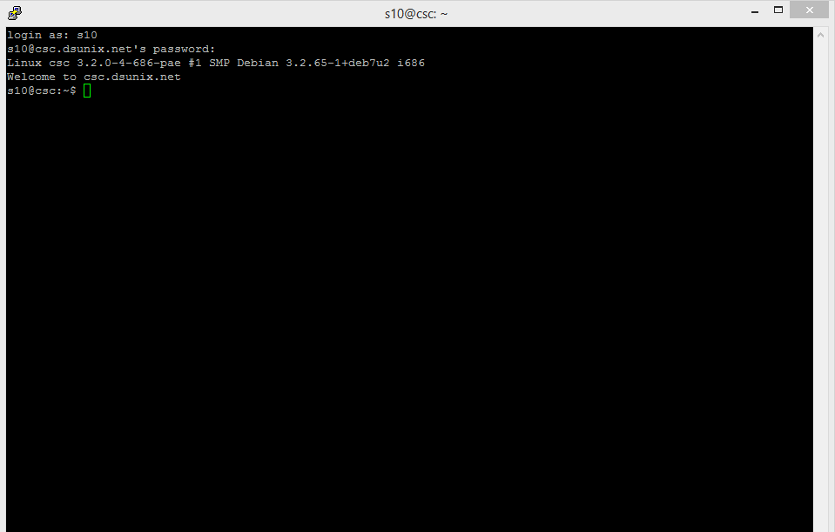

Part 2:

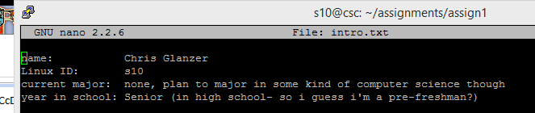

Part 3:

#include <stdio.h>

void passbyRef (int \*val){

int newNum;

printf("gimme a new number: ");

scanf("%d", &newNum);

\*val= newNum;

}

void passbyValue (int val){

int newNum;

printf("gimme a new number: ");

scanf("%d", &newNum);

val= newNum;

}

int main (){

int num;

int passbyNum;

int \*pointer;

pointer= &num;

printf("pick a number: ");

scanf("%d", &num);

printf("your number is %d", num);

printf("your choices are:\n");

printf(" (1) pass by reference\n");

printf(" (2) pass by value\n");

printf("choose: ");

scanf("%d", &passbyNum);

if (passbyNum==1){

passbyRef(pointer);

printf("\n");

printf("passing by reference should overwrite your old number, making your chosen number also: %d\$

}

else if (passbyNum==2){

passbyValue(num);

printf("\n");

printf("passing by value should only affect a copy of your old number, meaning your chosen number,$

}

return 0;

}